Student Wellbeing & Engagement Policy  (Child Safe) | 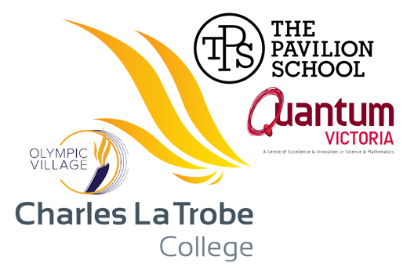

Charles La Trobe P-12 College takes a zero-tolerance approach to child abuse and is fully committed to ensuring that its strategies, policies, procedures and practices meet all Child Safety Standards as specified in Ministerial Order No. 1359 (2022).

RATIONALE
Our Student Wellbeing & Engagement Policy is enacted in order to fulfil our College Vision:
“Young people feel connected to our school and take pride in being a student here. They develop into inquisitive, literate and numerate life-long learners with a strong sense of community.
“We deliver a rich curriculum that motivates students to be engaged in their academic learning. Student data is used to inform and support both academic and wellbeing needs.
“We provide a nurturing learning environment that inspires high academic expectations and prioritises health and wellbeing to ensure each student feels safe, valued and respected as an equal member of our school community.”
Further the Department of Education and Training expects:
- A commitment to providing safe, secure and high quality learning and development opportunities for every student in all Victorian schools.
- That students will reach their full educational potential when they are happy, healthy and safe. This happens within a positive College culture that is fair, respectful and supports their learning.
- Charles La Trobe College to be an inclusive community within which all children and families experience belonging.

PURPOSE
The purpose of this policy is to ensure that all students and members of our school community understand:
- our commitment to providing a safe and supportive learning environment for students
- expectations for positive student behaviour
- support available to students and families
- our school’s policies and procedures for responding to inappropriate student behaviour.
Charles La Trobe College is committed to providing a safe, secure and stimulating learning environment for all students. We understand that students reach their full potential only when they are happy, healthy and safe, and that a positive school culture helps to engage students and support them in their learning. Our school acknowledges that student wellbeing and student learning outcomes are closely linked.
The objective of this policy is to support our school to create and maintain a safe, supportive and inclusive school environment consistent with our school’s values.

CONTENTS

RATIONALE 1
PURPOSE 1
CONTENTS 2
SCHOOL PROFILE 3
SCHOOL VALUES 4
IMPLEMENTATION 5
Enacting Our Values 5
A Response To Intervention (Rti) Approach To Wellbeing & Engagement Strategies: 7
ENGAGEMENT STRATEGIES – UNIVERSAL (TIER ONE) 9
Whole Of School 9
La Trobe Campus & Olympic Village PS 9
The Pavilion School 10
ENGAGEMENT STRATEGIES – TARGETED (TIER TWO) 12
Whole Of School 12
La Trobe & Olympic Village Campuses 12
The Pavilion School 13
ENGAGEMENT STRATEGIES – INDIVIDUAL (TIER THREE) 13
Whole Of School 13
The Pavilion School 14
Identifying Students In Need Of Support 15
Student Rights And Responsibilities 15
Student Behavioural Expectations And Management 16
La Trobe / Olympic Village Campus 16
USING THE VALUES MATRIX 17
NON-EXPECTED OR INAPPROPRIATE BEHAVIOURS 17
CLTC Behaviour Management Matrix 20
The Pavilion School 21
ENGAGEMENT WITH FAMILIES AND COMMUNITY 22
EVALUATION 22
COMMUNICATION 22
POLICY REVIEW AND APPROVAL 23
REFERENCES 24

SCHOOL PROFILE

Charles La Trobe P-12 College is a diverse and inclusive learning community. Charles La Trobe College is a multi-campus setting and operates under a ‘one’ college model. Our college campuses are La Trobe P-12 , Olympic Village, The Pavilion, with the Victorian Specialist S.T.E.M centre Quantum Victoria (also based at La Trobe). The work of staff is driven by commitment to our Instructional Model and Teaching and Learning Charter that are underpinned by our Professional Learning Communities. Our staff understand their students and expect that they will achieve to their full potential. We offer education programs that cater for students diverse interests to promote engagement in learning this enables each student to achieve to their full potential. The Berry Street Education Model (BSEM) is the foundation for our approach to wellbeing and engagement, and Ramon Lewis' Developmental Approach to Classroom Management guides our work with classroom and behaviour management. We compliment these approaches with Restorative Practices and the Classroom Mastery model. We build the capacity of all our learners to achieve their personal best. We are also very proud of our student cohort with all staff and students holding mutual strong expectations to live our values of respect, excellence, acceptance and leadership, everyday. Staff and students share and develop positive constructive relationships.

Our College is a vibrant organisation where each part of the organisation caters for contextual needs, while building powerful connections to each other. The La Trobe Campus currently has 375 enrolments, across Primary and Secondary, and an SFOE of 0.4704. In addition to our core curriculum, in which we focus upon developing literacy and numeracy skills and VCE and VCE VM, we offer a range of enriched I.T. opportunities including STEM Club, Minecraft, Animation Club, Astronomy Club and Media Club. Our STEM programs prepare students for the future world of work, in which creativity and problem solving will be critical skills are well supported by our partnership with Quantum Victoria, which operates onsite. La Trobe Primary campus operates a Kitchen Garden Program as well as Instrumental Music. La Trobe has excellent learning spaces, built for transparency yet enclosing of sound, with teaching conducted in rooms which promote a safe and orderly learning environment. La Trobe Facility caters for hearing impaired students with classrooms equipped with hearing technology and our staff comprised of interpreters as well as the College running AUSLAN from Primary to Secondary. The Facility program provides positive education experiences for secondary aged students who are deaf or are hard of hearing and we are able to extend many supports to primary students at La Trobe.

The International Student Program, operating at both La Trobe and Olympic Village supports our students to become members of the global community. The College currently has 20 International students with enrolment steadily increasing year to year. Engagement with the community and promotion of diversity are highly valued aspects of College life. We offer a REAL Education curriculum (based on our school values) to enable students to develop strong interpersonal and social capabilities. We pride ourselves on being a community that welcomes all students and families. Our International Student Program supports our students to become members of the global community.

All campuses is are heavily invested and involved in the Science of Language and Reading (SOLAR), Writing Across the Curriculum (WATC) and Science of Math (SOM) in partnership with La Trobe University. Staff across the college work in Professional Learning Communities, additionally at the La Trobe Campus small teams of teachers work in Professional Engagement Teams (PETs) where they drive an Action Research Cycle to focus on improving student outcomes in frequent and regular rotations. In our secondary setting we have a full VCE program offering 22 studies.

Olympic Village is a campus of Charles La Trobe P-12 College and is located in Heidelberg West. The campus currently has an enrolment of 137 students, and a SFOE of 0.594. A grant of over $6 million dollars was received in 2018 to re-build the site entirely. This building work was completed in September 2019. Seven stand alone grades are in operation with 7 international students. 23 students receive PSD/DI Funding and recent data is showing signs of growth across cohorts for NAPLAN.

The Pavilion campuses (East Preston and Epping) support 220 students with challenging needs via a highly differentiated and personalised learning program to meet the needs of young people. The Pavilion School is a Victorian state secondary school for students who have previously been disengaged or had significant challenges with approaches to schooling. It is governed by Charles La Trobe College under the one college approach. Pavilion students present at school with a range of behavioural difficulties and risk factors, and every class is supported by wellbeing staff. At The Pavilion, students work in small multi age and ability groups. Teaching staff at the Pavilion work in professional learning teams and teach across Literacy, Numeracy, Work Related Skills and Personal Development subjects. Pavilion staff have a proven ability to work with high-risk youth and experience dealing with students with a complex range of personal issues. Most students participate in the VCE, Vocational Major or Victorian Pathways Certificate. Characterised by a calm and therapeutic environment and approach, Pavilion aims to provide a positive educational experience for all its students. The Pavillion campus of Charles La Trobe P-12 College works tirelessly to ensure cultural safety and understanding in all practices.

Charles La Trobe College is committed to providing enrichment education experiences for all our students. This goal is supported by our partnerships with La Trobe University and Quantum Victoria. Quantum Victoria is an important part of our College, and is one of six State specialist Mathematics and Science Centres. This partnership provides a breadth of Science and Mathematics extension and enrichment program for our students. Our partnership with La Trobe University includes:

· Science of Language and Reading (SOLAR) the highly regarded Literacy Professional Learning pilot with Professors Pam Snow and Tanya Serry

· Access to La Trobe Sporting facilities and programs

· Achieve at La Trobe access to university subjects for VCE students

· Prepare for La Trobe - free preparatory courses that include a non-ATAR entry alternative for both VCE and VCAL students

· Extended Pre-service Placement an extended, application only pre-service program which stretches across the academic year

· School Partnership Program an immersion program designed to promotes university as a post-school pathway for secondary aged students

· Nexus an internship program for pre-service teachers

At Charles La Trobe P-12 College we believe every student should be supported to learn to their full potential: to achieve their best and to be their best. All positions advertised are at the employment of Charles La Trobe College. This position is initially intended to be based at the La Trobe P-12 Campus, overseeing Secondary. All Assistant Principals balance their time with Campus duties and an allocated area of F.I.S.O 2.0 across the College.

SCHOOL VALUES
The La Trobe Campus and Olympic Village Primary School’s REAL Values support the College’s work in curriculum, wellbeing and engagement. Our REAL Values are enshrined as follows:
Respect: We protect the right of all students to learn and teachers to teach; mutual respect and personal responsibility of all members of the College community help us to provide a safe and orderly learning environment.
Excellence: We encourage our staff and students to be reflective, disciplined, resilient and confident, to support deep levels of thinking and understanding.
Acceptance: We believe diversity is a strength; we promote diverse ways of learning, thinking and knowing to cultivate open minds and the willingness to take risks to solve new problems. We are inclusive and build positive relationships by accepting one another.
Leadership: We believe that strong leadership is vital for our community to thrive. Our student and staff leadership teams are responsive to those they serve, inclusive and visionary. We encourage all students to think and behave as leaders by supporting them to be self-motivated, disciplined and by setting high expectations of themselves.
At The Pavilion School
Learning: we value the power of education to improve our lives, we value school attendance, and we value engaging and calm classes.
Respect: we have respect for each other and for ourselves and value a diverse school community.
Safety: we respect personal safety, and our behaviour ensures the safety of others
Personal growth: we take responsibility for our behaviour and are always working towards positive change in our lives.

IMPLEMENTATION

Enacting our Values
At Charles La Trobe College we promote positive, non-discriminatory relationships among students, parents/carers, staff and the wider community. Every member of the College community has a right to fully participate in an educational environment that is safe, supportive and inclusive. Everyone deserves to be treated with respect and dignity.
The Charter of Human Rights and Responsibilities Act 2006:
The Charter sets out a list of 20 rights that reflect the following four basic principles: Freedom, Respect, Equality and Dignity. The Charter outlines a vision of human rights for all Victorians. The Charter affirms that all people are born free and equal in dignity and rights. While the Charter demands equality for all, it also emphasises the value of difference. The Charter requires public authorities, including government schools and their employees, to act compatibly with human rights and to consider human rights when making decisions and delivering services:
- The right not to be discriminated against
- The right to privacy and reputation
- The right to freedom of thought, conscience, religion and belief
- Cultural Rights
With human rights comes a responsibility to respect others’ human rights. All DET employees must act compatibly with the Charter and give proper consideration to human rights when making decisions. Everyone should:
- Encourage compliance with the Charter
- Support others to act compatibly with the Charter, and
- Respect and promote human rights.
Charles La Trobe College has developed shared expectations to ensure that the learning, safety and rights of all are respected. The expectations are intended to be positive in that they set out what is accepted and appropriate behaviours for our college community. Our shared expectations are intended to support individual students and families that come to our community from a diversity of backgrounds, communities and experiences. College expectations include:
- inclusive teaching practices
- accessible educational provision for all students
- strong parent/carer partnerships and liaison
- community partnerships which engage families and the community in ways that support student achievement and success
- provision of appropriate student services
- development and provision of appropriate, relevant and challenging curriculum that gives students the opportunity to experience success in their learning.
At Charles La Trobe College, we strongly endorse the following: Every member of the school community has a right to fully participate in an educational environment that is safe, supportive and inclusive. We promote diversity and tolerance, and people from all walks of life and cultural backgrounds are welcome. In particular we:
- promote the cultural safety, participation and empowerment of Aboriginal and Torres Strait Islander students
- promote the cultural safety, participation and empowerment of students from culturally and/or linguistically diverse backgrounds
- ensure that students with a disability are safe and can participate equally in all aspects of school life
- ensure that LGBTIQA+ students are safe and can participate equally in all aspects of school life
The school understands that for Aboriginal people, culture is about family networks, Elders and ancestors. It is about relationships, languages, dance, ceremony and heritage. Culture is about spiritual connection to lands and waters. It is the way stories are passed on and knowledge given to babies and students. It is how people are greeted. It is looking for connection. It is about all the parts that bind us together.
The school recognises that creating a physical environment that is respectful of Aboriginal culture is an important first step. Symbols and images that surround a place send an important message about respect. By acknowledging the Country in which the school is located, we are demonstrating our willingness to learn, understand and respond to the diversity of Aboriginal cultures. ‘Acknowledgement of Country’ forms part of College ceremonies and meetings.
The school recognises that cultural safety is living in an environment that is safe for people, where there is no assault, challenge or denial of their identity, of who they are what they need. It is about shared respect, shared meaning, shared knowledge and experience, of learning, living and working together with dignity and truly listening. The school recognises that promotion of cultural safety of students from culturally and/or linguistically diverse backgrounds involves:
- ensuring the College clearly demonstrates a zero tolerance of discrimination
- being respectful, inclusive and welcoming of families from a range of backgrounds
- recognising times of importance to different cultures
- ensuring the physical environment has a positive image of a range of cultures, in terms of decoration and artwork
- employing staff that are representative of the local community
- actively seeking out and talking to families about how they would like to be involved
- asking about the best way to provide information to students and families.
The school recognises that respecting diversity means:
- valuing and respecting people’s beliefs
- building responsive relationships
- communicating openly and honestly to find out how best to be inclusive and respect cultural needs
- examining our personal ideas, customs and beliefs
- respecting that the beliefs of one person may not be the same as another
- acknowledging and respecting that others can hold different beliefs of equal significance.
Cultural understanding, awareness, safety and pride is ensured by:
- The development and review of Koorie Education Plans for Aboriginal and Torres Strait Islander students
- The holding of culturally inclusive educational activities; cultural yarning circles, Koondee Ngarrngi Group, Aboriginal and Torres Strait Islander history and geography curriculum programs in our planning, excursions and camps
- Ensuring curriculum programs have Aboriginal and Torres Strait Islander perspectives woven through out.
- Selection of texts by Aboriginal and Torres Strait Island writers, film-makers and scholars in our curriculum programs
- The establishment and implementation of Reconciliation Action Plans
- Employment of key Aboriginal and Torres Strait Islander personnel.
- Leadership positions for Aboriginal and Torres Strait Island personnel.
- Acknowledgement of, and celebration of special days of recognition, Sorry Day, Reconciliation Week, NAIDOC Week.
- Attendance support initiatives for Aboriginal and Torres Strait Island Students
The school’s Anti-Discrimination Policy describes the school’s commitment to providing teaching and learning environments that are free from discrimination in all forms, including those based on race, ethnicity, gender, ability, disability, sexuality and religion. Antidiscrimination extends to the school’s dress code so that students are treated equally with the rights of individual students balanced against the best interests of the school community as a whole when developing and implementing their dress codes.
The College Principal will work with sub-school principals, campus principals and the OHS teams to ensure that when required adjustments will be made to facilities, grounds and buildings to ensure equal opportunity for students with a disability.
- We equip and empower our students to explore, have aspirations and discover their full potential – to strive, to seek and to excel.
- We endeavour to live our College values of respect, excellence, acceptance and leadership every day.
At Charles La Trobe College we acknowledge the equality of worth, dignity and self-respect shared by all members of the College community: students, teachers, staff, families, neighbours and others.
- We celebrate the multicultural mix of those within our college community and the world around us.
- We acknowledge the diversity of individuals and families, beliefs and practices, lifestyles and customs, which are contained within and outside our college community.
- We affirm and respect the differences between individuals and each person’s right to enjoy a safe and nurturing environment.
- We are committed to our role as educators and role models to provide a positive and safe school where our students are free to explore themselves and their world, and to practice the skills necessary for them to become fully educated, aware, compassionate and empowered citizens.
- We recognise the policies and principles contained within the laws and ethical frameworks of our society, whereby all people are to be treated equally and with respect; and which place responsibility upon individuals and Colleges to provide a safe and caring environment.
- At Charles La Trobe College we are committed to providing a range of programs and strategies to promote student engagement, high attendance and positive behaviours.

A Response to Intervention (RtI) Approach to Wellbeing & Engagement Strategies:
Using the RtI framework allows the college to allocate resources and people where they will have most impact. Accordingly we have grouped our strategies and interventions, where:
- Tier One activities, strategies and interventions are provisioned universally across the college or across a campus, having influence across many students or cohorts.
- Tier Two activities, strategies, and interventions target groups of students with particular needs, or a cohort with a clear emerging theme that needs to be addressed.
- Tier Three activities, strategies and interventions are highly intensive, and provisioned to support individuals.

ENGAGEMENT STRATEGIES – UNIVERSAL (TIER ONE)

Whole of School
At Charles La Trobe College our College culture is predicated on student engagement being the basis for learning. To support this, our leadership and wellbeing teams work with teachers to support them to develop classroom practice that ensures our pedagogy and curriculum engages all students. Effective teaching, inclusive and engaging curriculum and respectful relationships between staff and students are promoted through staff professional learning communities and professional engagement teams. We also have clearly articulated schoolwide and classroom expectations and consequences.
A comprehensive and flexible curriculum provides for the needs and individual differences of each student. We acknowledge, value and respect student achievements through awards, Compass chronicle posts, assemblies and social media.
Students are encouraged to participate in a broad range of core and extra-curricular activities such as:
- Advance Program
- Student Leadership, including Rotary Interact Group and ‘Grip’ leadership conference
- Sporting competitions
- Community programs
- La Trobe University Partnership Initiatives
- Lunchtime Clubs
- Friday Programs
- Duke of Edinburgh Award elective
- Community Service and La Trobe Aspire Program

La Trobe Campus & Olympic Village PS
- Our Teaching and Learning Charter clearly articulates our shared approach to teaching and learning.
- We implement strategies from the trauma informed Berry Street Education Model:
  - Body, Relationships, Stamina, Character, Engagement
- We follow the Ramon Lewis Developmental Management Approach.
- We implement the shared expectations from our REAL Values Matrix. The matrix was developed in partnership with our students.
- We are technologically innovative and offer a broad range of enrichment activities, in addition to our core curriculum. Our STEM and STEAM programs prepare students for the future world of work, in which creativity and problem solving will be critical skills.
- We harness student voice and agency through the student leadership programs, and by providing opportunities for students to influence change within the College community (lunch with the principal, participation on school council).
- We ensure students are included on school council and hold regular meetings to which leadership/principal class employees are invited to receive feedback. Students are also invited to forums to ensure there are school-wide and classroom processes for ongoing collection and use of student feedback data for decision-making.
- We ensure staff professional learning is given high priority to ensure strategies and approaches are adopted and implemented – Professional Learning Communities and Professional Engagement Teams include a focus on action research and evidence-based practice.
- We use and access the Be-You framework for health promotion and educator wellbeing.
A comprehensive and flexible curriculum provides for the needs and individual differences of each student. We acknowledge, value and respect student achievements. Students are encouraged to participate in a range of an extra-curricular activities such as:
- Instrumental music and performing arts programs (choir, band, productions)
- Clubs and extra-curricular activities (Chess Club, Drama Club, Minecraft project, STEM Club)
The College encourages parents/carers to become co-operative partners with teachers in developing positive educational outcomes for students. Parents/carers have opportunities to be elected to College Council. They are welcome as volunteers in the College across a range of programs (for example; Primary School reading and swimming/whole of College breakfast club).
We support parents to maximise student attendance and provide financial assistance where required to ensure maximum access to programs, uniform and resources.
Termly parent-teacher-student interviews and student support group meetings provide opportunities for students to share goals and reflections with their parents/carers and set new/modified goals for the coming semester/term.
The College provides multiple opportunities for proactively engaging parents/ carers to be involved in supporting students with complex needs (for example: disabilities, mental health or traumatised) by:
- recognising and responding to the diverse needs of our students through the PSD Support program and implementation of the Universal Design for Learning
- implementing the Universal Design for Learning to engage students in meaningful learning experiences
- ensuring Wellbeing Team Members (including Year Level Leaders, SWOs, and others) work closely with students who are at risk to maximise engagement at school
- providing a range of education support officers to facilitate inclusion; our ES team includes a speech therapist, a social cohesion officer, a behaviour support integration aides, student welfare officer, a school nurse, reading remediation aides and school librarians
- providing high level support to students with concerning attendance
- providing intensive literacy and numeracy improvement programs as part of the College improvement agenda.
- we celebrate student achievements at student led sub-school assemblies; we provide REAL Awards and attendance awards and showcase student led activities/achievements.
- students present their work through termly ‘expos’ related to curriculum experiences to ensure learning is meaningful; for example City Experience team presentations, talent shows, interschool sports and Lion’s Club Youth of the Year public speaking event
- students run a range of termly awareness and fundraising activities such as Harmony Day, Wear It Blue and Multi-cultural day
- there is a school-wide attendance strategy and online wellbeing support referral form to identify vulnerable students and those at risk of disengagement from school
- Our open plan learning environment
- The work of teachers is driven by a growth mindset: we believe every student can achieve and we have high expectations of all learners.
- Our open learning spaces promote teaching as a public practice and enable us to create a safe and orderly learning environment.
- Universal (Tier One) services, programs and supports provided by Mental Health Practitioner, Secondary School Nurse

The Pavilion School
The Pavilion School has developed a range of strategies to promote engagement, positive behaviour and respectful relationships for all students in our school. We acknowledge that some students may need extra social, emotional or educational support at school, and that the needs of students will change over time as they grow and learn.
The Pavilion School’s wellbeing framework was developed through a combination of clinical experience and evidence-based practice on child and adolescent development, mental health, trauma-informed practice, and wellbeing. We integrate these knowledge areas with student observation and professional reflection.
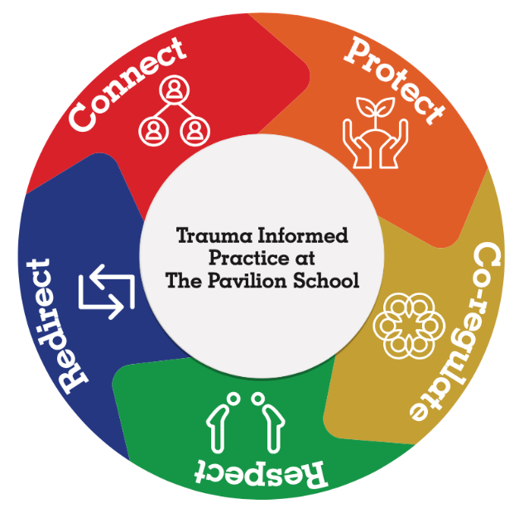
The majority of engagement strategies are delivered to the whole school community. This follows a universal design for learning approach which aims for all staff and every classroom to be equipped to for a diverse student community. A summary of the universal (whole of school), targeted (group specific) and individual engagement strategies used by our school is included below:
- Welcoming intake and enrolment process for students and families that addresses the power imbalance at play with schools, families and students.
- Welcoming all parents/carers and being responsive to them as partners in learning
- High and consistent expectations of all staff, students and parents and carers
- Demonstration of unconditional positive regard for all students
- Universal design of classroom support featuring a teacher, a youth worker and a teacher assistant in every classroom.
- Team around the learner approach to student planning and support including assessing student need, developing student case plans and developing student individual learning plans.
- Following Reconciliation Action Plan to ensure school is culturally safe for Aboriginal and Torres Strait Islander students.
- Prioritisation of development of safe, consistent and supportive relationships between staff and students, recognising the fundamental role this plays in building and sustaining student wellbeing
- Delivery of a broad curriculum including VCAL, VET, outreach teaching and individualised lessons to ensure that students are able to choose subjects and programs that are tailored to their interests, strengths and aspirations.
- Use of the Pavilion instructional framework to ensure an explicit, common and shared model of instruction to ensure that evidenced-based, high yield teaching practices are incorporated into all lessons.
- School’s Statement of Values are incorporated into our curriculum and promoted to students, staff and parents so that they are shared and celebrated as the foundation of our school community
- School attendance is encouraged, monitored contact with parents is prioritised.
- Student voice is encouraged by providing opportunities for student leadership, student feedback and participation in decision making.
- Behavioural expectations are explicitly taught school wide and consistently applied by every staff member.
- We engage in school wide programs such as:
  - Respectful Relationships
  - Safe Schools
  - Whole school pathways and transitions programs that seek to engage all students in exposure to the world of work and further education.
- Every student completes the Australian Index for Adolescent Development (Swinburne University) which assesses student risk of homelessness, student self- esteem, student connectedness to school.

ENGAGEMENT STRATEGIES – TARGETED (TIER TWO)

Whole of School
At Charles La Trobe College we resource a range of targeted engagement strategies, including the promotion of the safety of students with a disability:
- acknowledging that students with a disability are particularly vulnerable and ensure risk assessment processes considers their needs
- ensuring the school clearly demonstrates a zero tolerance to discrimination and actively welcomes all students
- making sure the environment does not pose access difficulties
- being responsive to families regarding specific measures that may be required to ensure the safe participation of a child with a disability
- supporting staff, other students and their families to understand and be inclusive of people with a disability
- thinking about how the school can encourage participation and feedback from students with a disability and their families.

La Trobe & Olympic Village Campuses
- at primary school year levels, both campuses have a Wellbeing Coordinator who is responsible for monitor the health and wellbeing of students in partnership with classroom teachers and members of the school leadership team. They also act as a point of contact for students who may need additional support
- at secondary year levels each year group has a Year Level Leader, a senior teacher responsible for their year, who monitor the health and wellbeing of students in their year, and act as a point of contact for students who may need additional support
- Koorie students are supported to engage fully in their education, in a positive learning environment that understands and appreciates the strength of Aboriginal and Torres Strait Islander culture. We connect with Regional and Pavilion Staff to support this work.
- our English as a second language students are supported through our EAL program, and all cultural and linguistically diverse students are supported to feel safe and included in our school including through the appointment of a EAL Coordinator.
- we support learning and wellbeing outcomes of students from refugee background through the employment of wellbeing staff from diverse backgrounds, including the appointment of a Social Cohesion Officer.
- we provide a positive and respectful learning environment for our students who identify as LGBTIQA+ and follow the Department’s policy on LGBTIQ Student Support
  - Weekly student led love-club
  - RRRRiS in REAL Ed Curriculum
  - Inclusion Days are celebrated.
- all students in Out of Home Care are supported in accordance with the Department’s policy on Supporting Students in Out-of-Home Care including being appointed a Learning Mentor, having an Individual Learning Plan and a Student Support Group (SSG), connection with Lookout and being referred to Student Support Services for an Educational Needs Assessment
- students with a disability are supported to be able to engage fully in their learning and school activities in accordance with the Department’s policy on Students with Disability, such as through reasonable adjustments to support access to learning programs, consultation with families and where required, student support groups and individual education plans
- wellbeing and health staff will undertake health promotion and social skills development in response to needs identified by student wellbeing data, classroom teachers or other school staff each year
- staff will apply a trauma-informed approach to working with students who have experienced trauma. This is further supported by high-level professional learning with Berry Street Education Model.
- students enrolled under the Department’s international student program are supported in accordance with our legal obligations and Department policy and guidelines at: International Student Program
- all students from Year 9 and above will be assisted to develop a Career Action Plan, with targeted goals and support to plan for their future
- targeted (Tier two) services, programs and supports provided by Mental Health Practitioner, Secondary School Nurse
- Charles La Trobe College assists students to plan their Year 10 work experience, supported by their Career Action Plan

The Pavilion
- Aboriginal Cultural program delivered in tandem with VACCA and Stronger Brother Stronger Sister
- Co-located YSAS Drug and Alcohol clinician on site one day per week
- Co-located Doctors in Schools Program with nurse and GP on site one day per week
- Access to school psychologist and psychotherapist for students requiring mental health support.
- Outreach and engagement program for highest risk students and those with very low attendance.
- Students in Out of Home Care will be appointed a Learning Mentor, have an Individual Learning Plan and will be referred to Student Support Services for an Educational Needs Assessment
- Young women’s Group – support provided to young women in a group setting, with group topics generated by students.
- Young men’s group – Support provided to young men in a group setting.
- LGBTIQ group – support provided to gender diverse students.

ENGAGEMENT STRATEGIES – INDIVIDUAL (TIER THREE)

Whole of School
Charles La Trobe College implements a range of strategies that support and promote individual engagement. These can include:
- building constructive relationships with students at risk or students who are vulnerable due to complex individual circumstances
- meeting with student and their parent/carer to talk about how best to help the student engage with school
- developing an Individual Learning Plan and/or a Behaviour Support Plan
- Individual (Tier three) services, programs and supports provided by Mental Health Practitioner, Secondary School Nurse and external agencies
- The consideration of environmental changes that need to be made, for example changing the classroom set up
- referring the student to:
  - school-based wellbeing supports
  - Student Support Services
  - Appropriate external supports such as council-based youth and family services, other allied health professionals, headspace, child and adolescent mental health services or ChildFirst
  - Re-engagement programs such as Navigator and Lookout.
Where necessary the school will support the student’s family to engage by:
- being responsive and sensitive to changes in the student’s circumstances and health and wellbeing
- collaborating, where appropriate and with the support of the student and their family, with any external allied health professionals, services or agencies that are supporting the student
- monitoring individual student attendance and developing an Attendance Improvement Plans in collaboration with the student and their family
- engaging with our regional Koorie Engagement Support Officers
- running regular Student Support Group meetings for all students:
  - with a disability
  - in Out of Home Care
  - with other complex needs that require ongoing support and monitoring.

The Pavilion
- Every student is allocated a youth worker who:
  - Measures risk factors in a student’s life
  - Assesses student need
  - Formulates student social/emotional situation
  - Develops a case plan including planned interventions for each student.
  - Organises a student support group for all students mandated (out of home care, ATSI and students on the PSD) and any other student that requires it.
- Teachers develop individualised curriculum for students who are unwilling to participate in group class work.
- Outreach youth workers and teacher are allocated to students at high risk and with very low attendance (less than 10%).

Identifying Students in Need of Support
Charles La Trobe College is committed to providing the necessary support to ensure our students are supported intellectually, emotionally and socially. The Student Wellbeing team plays a significant role in developing and implementing strategies help identify students in need of support and enhance student wellbeing. Charles La Trobe College will utilise the following information and tools to identify students in need of extra emotional, social or educational support:
- Staff professional learning on suicide prevention (STORM); suicide risk continuum training, and NIP (notice inquire provide)
- Be-You provides us with suicide post-vention training and resources.
- personal, health and learning information gathered upon enrolment and while the student is enrolled
- attendance records
- there is a school-wide attendance strategy and online wellbeing support referral form to identify vulnerable students and those at risk of disengagement from school
- academic performance
- observations by school staff such as changes in engagement, behaviour, self-care, social connectedness and motivation
- attendance, detention and suspension data
- engagement with families
- self-referrals or referrals from peers

Student rights and responsibilities
All members of our school community have a right to experience a safe and supportive school environment. We expect that all students, staff, parents and carers treat each other with respect and dignity. Our school’s Statement of Values highlights the rights and responsibilities of members of our community.
Students have the right to:
- to be safe
- learn and do their work
- participate fully in their education
- feel safe, secure and happy at school
- learn in an environment free from bullying, harassment, violence, racism, discrimination or intimidation
- express their ideas, feelings and concerns.
Students have the responsibility to:
- participate fully in their educational program
- display positive behaviours that demonstrate respect for themselves, their peers, their teachers and members of the school community
- respect the right of others to learn.
Students who may have a complaint or concern about something that has happened at school are encouraged to speak to their parents or carers and approach a trusted teacher or a member of the school leadership team. Further information about raising a complaint or concern is available in our Complaints Policy.

Student behavioural expectations and management
Behavioural expectations of students are grounded in our school’s Statement of Values/Student code of conduct.
Violence, bullying, and other offensive and harmful behaviours such as racism, harassment and discrimination will not be tolerated and will be managed in accordance with this policy. Bullying will be managed in accordance with our Bullying Prevention Policy.
When a student acts in breach of the behaviour standards of our school community, Charles La Trobe College will institute a staged response, consistent with the Department’s policies on behaviour, discipline and student wellbeing and engagement. Where appropriate, parents will be informed about the inappropriate behaviour and the disciplinary action taken by teachers and other school staff.
Our school considers, explores and implement consequential and non-punitive interventions to support student behaviour before considering disciplinary measures such as detention, withdrawal of privileges or withdrawal from class.
Disciplinary measures may be used as part of a staged response to inappropriate behaviour in combination with other engagement and support strategies to ensure that factors that may have contributed to the student’s behaviour are identified and addressed. Disciplinary measures at Charles La Trobe College will be applied fairly and consistently. Students will always be provided with an opportunity to be heard.
Disciplinary measures that may be applied include:
- warning a student that their behaviour is inappropriate
- teacher controlled consequences such as moving a student in a classroom, temporary relocation or other reasonable and proportionate responses to misbehaviour
- withdrawal of privileges
- referral to the Year Level Coordinator / Assistant Principal
- restorative practices
- detentions
- behaviour support and intervention meetings
- suspension
- expulsion
Suspension, expulsion and restrictive interventions will be used in situations consistent with Department policy, available at:
- https://www2.education.vic.gov.au/pal/suspensions/policy
- https://www2.education.vic.gov.au/pal/expulsions/policy
- https://www2.education.vic.gov.au/pal/restraint-seclusion/policy
In line with Ministerial Order 1125, no student aged 8 or younger will be expelled without the approval of the Secretary of the Department of Education and Training.
The Principal of Charles La Trobe College is responsible for ensuring all suspensions and expulsions are recorded on CASES21.
Corporal punishment is prohibited by law and will not be used in any circumstance at our school.

La Trobe / Olympic Village Campus
The College has high expectations of students’ behaviour and follows a College-wide student management process (Developmental Management Approach) based on an approach developed by Ramon Lewis. The approach emphasises the importance of building strong relationships between staff and students, provides students with choice, aims to allow teachers to teach and students to learn, involves parents/carers, promotes self-discipline and focuses on creating a positive, supportive learning environment. The basic tenets of the approach are:
- Student individual academic reports will include details regarding students’ learning ready behaviours.
- The College will engage the services of successful young people as guest speakers or workshop facilitators to act as positive role models.
- Shared Expectations are negotiated with students and the Student Representative Council.
- A wide range of positive extra-curricula activities will be provided for students including sporting, leadership, community service and appropriate leisure pursuits.
- An up-to-date database of student behaviour on Compass will be maintained.
- All staff will undertake professional development on student behaviour management and support.
- The College curriculum will include units on resilience, peer pressure, positive choices, bullying, cyber-bullying, conflict resolution and leadership (REAL Education specifically and more broadly across the curriculum).
- Students experiencing difficulty achieving positive behavioural outcomes will undertake individualised behaviour management programs focussing upon agreed goals.
- Consequences for ongoing inappropriate behaviour may include counselling, loss of privileges or suspension.
- Parents will be kept informed, and actively encouraged to assist in increasing their child’s engagement at school.

Using the Values Matrix
The REAL Values Matrix sets out the expectations for Student Behaviour on the La Trobe Campus
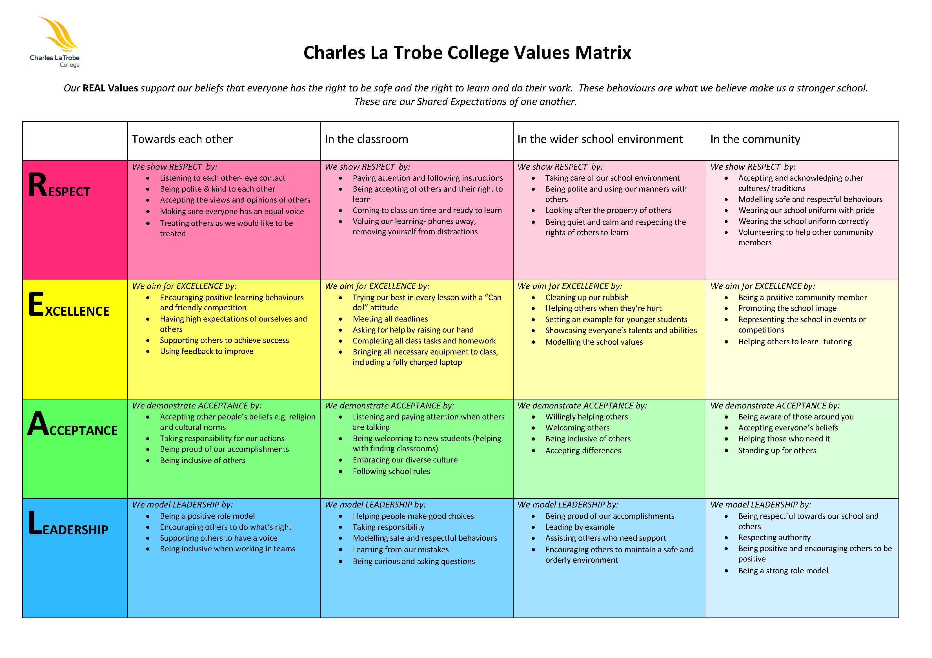

Non-expected or Inappropriate Behaviours
Harassment is any verbal, physical or sexual conduct (including gestures) which is uninvited, unwelcome or offensive to a person.
Bullying is repeated oppression, physical or psychological, of a less powerful person by a more powerful person or group.
Cyberbullying is a form of bullying which is carried out through an internet service such as email, chat room, discussion group, online social networking, instant messaging or web pages. It can also include bullying through mobile phone technologies such as SMS. It may involve text or images (photos, drawings). Examples of cyberbullying behaviour are: teasing and being made fun of, spreading of rumours online, sending unwanted messages, defamation and requesting/sending explicit text messages or images.
Charles La Trobe College has zero tolerance of bullying and of harassment in any form. The wellbeing of every child and young at the College is our highest priority.
- We acknowledge our legal and moral obligations to contact authorities when we are worried about a child’s safety.
- We are committed to preventing child abuse and identifying risks early, and removing and reducing these risks.
- We have robust human resources and recruitment practices for all staff and volunteers.
- We are committed to regularly training and educating our staff and volunteers on child abuse risks.
- We have specific policies, procedures and training in place that support our leadership team, staff and volunteers to achieve these commitments.
- We recognise that developing a child safe environment is an ongoing process and will not be achieved in the short term. Implementing the Child Safe Standards requires an ongoing commitment. It will not be achieved in one activity or exercise.
The school encourages all students to speak up when bullying or harassment is encountered.
- We take a whole-school approach focusing on safety and wellbeing
- We consistently respond to all incidents of bullying that have been reported to the school and ensure that planned interventions are used to respond to these incidents
- We ensure that support is provided to any student who has been affected by, engaged in or witnessed bullying behaviour
- We provide regular updates, within the bounds of privacy legislation, to parents or caregivers about the management of incidents
- All concerns are taken seriously. All complaints are treated confidentially.
Student positive behaviours will be supported through relationship based whole-College and classroom practices and shared expectations, including:
- establishing clear processes for student management and student attendance
- establishing predictable, fair and democratic classrooms and College environments
- ensuring student participation in the development of classroom and whole College expectations
- providing personalised learning programs where appropriate for individual students
- empowering students by creating multiple opportunities for them to take responsibility and be involved in decision-making
- providing physical environments conducive to positive behaviours and effective engagement in learning
- providing pro-active programs to promote student engagement, positive behaviours and regular attendance.
Inappropriate behaviours, including irregular attendance, will be responded to through a staged response, including:
- understanding the student’s background and needs
- ensuring a clear understanding of expectations by students, parents and teachers
- providing consistent, teacher expectations and classroom environments
- scaffolding the student’s learning program
- communicating with the parents/carers
- specific monitoring of student behaviour and attendance.
Broader support strategies will include:
- involving and supporting the parents/carers
- involving the Principal, student wellbeing coordinator, nurse, psychologist, Managed Individual Pathways or Careers coordinators
- tutoring/peer tutoring, mentoring and/or counselling
- convening student support group meetings – the student support group is an important component of the staged response for students facing difficulty with engagement, attendance or behaviour
- developing individualised flexible learning, behaviour or attendance plans
- providing broader educational programs, for example experiential learning, work education, camps/outdoor education/creative arts
- involving community support agencies.
Relocation, Homework Redemption and Detention
- In line with the Developmental Management Approach students may be relocated from their classroom if they fail to meet shared expectations (after two warnings/reminders).
- Students are required to meet with their teacher during recess and lunch following a ‘relocation’ for a restorative conversation.
- Teachers may require a student to finish work which has not been completed in the regular classroom, or to undertake additional or new work or duties at a reasonable time and place. No more than half the time allocated for any recess may be used for this work.
- Where students are required to undertake school work out of College hours, the time should not exceed forty-five minutes.
- If students do not attend homework/classwork redemption settings, do not attend restorative conversations and repeatedly breach College expectations they may be issued an after school detention.
- The College Principal should ensure that parents are informed at least 24 hours prior to the detention. The College will ensure arrangements do not cause undue family hardship.
- Charles La Trobe College is permitted to detain students but will take into account family circumstances and negotiate with parents where appropriate.
- Students who repeatedly breach expectations will be supported by the Year Level leader by the initiation of individual contracts and implementation of behaviour support plans. In these cases parents/carers will be asked to attend a student support group meeting.

CLTC Behaviour Management Matrix
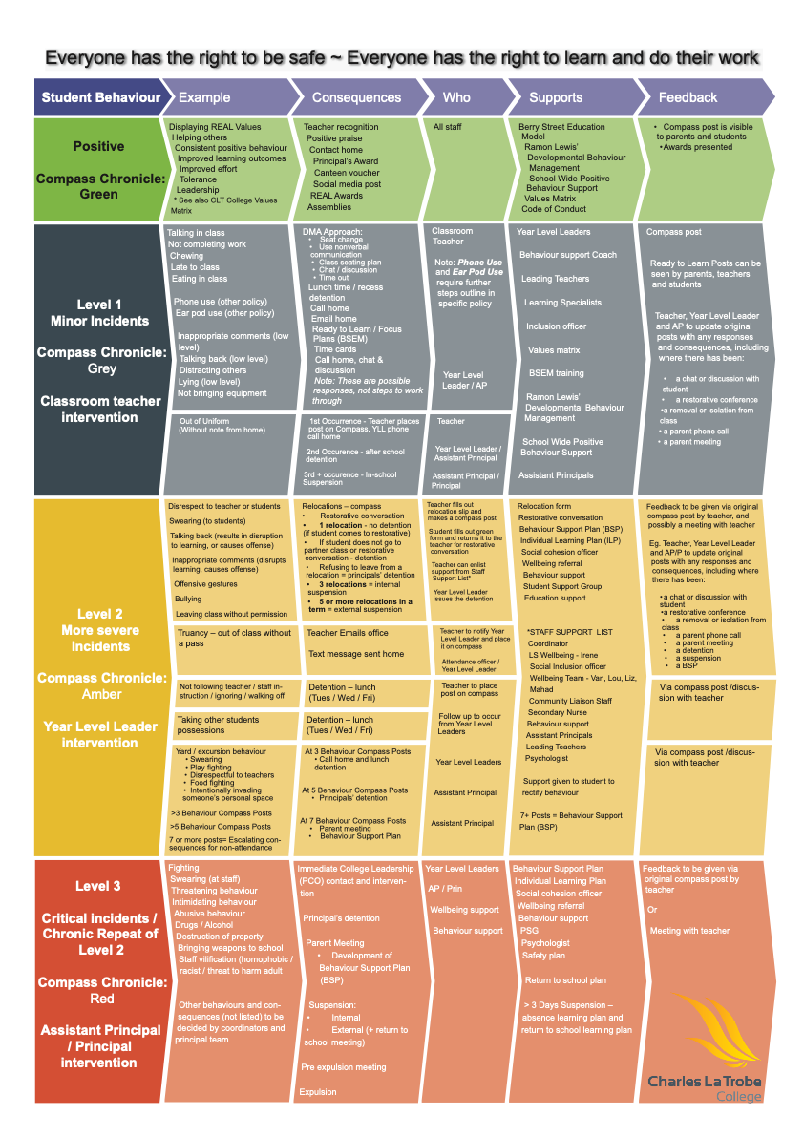

The Pavilion
These three expectations are explicitly taught at the beginning of each term and reflected on regularly (every day if behaviour is consistently difficult)
- We are safe and respectful at school
- We participate in school work while at school
- We allow all students to work free from disruptions
When students cannot meet expectations a shared school wide approach is followed:
Step 1: Prevention. Make agreements with class groups and individual students about these expectations and seek permission to implement consequences if expectations are broken. Write up classroom expectations and display in classroom.
Step 2: Reminder. Quietly ask the student for the behaviour you would like to see and remind them of class expectations. Ask them if you can help them comply with expectations.
Step 3: Second Reminder. Quietly ask the student for the behaviour you’d like to see AND tell them that if it continues then they’ll need to talk out of the classroom.
Step 4: Student leaves classroom with staff member. Calmly ask student to follow you to out of the classroom for a chat. Talk with the student about what you expect them to do in class. Connect with student’s emotional state. If the student can commit to trying again, the student returns to class and goes back to step 1. If they can’t then move to step 5.
Step 5: Ask the student to leave the classroom with you. Explain to the student that they can’t go back into class because they couldn’t meet the classroom expectations. Make a plan with the student about what happens next, that they are still welcome in the school but that the behaviour is unacceptable
- Call student’s parent/carer and inform about the behaviour.
- A plan is made for student to be picked up, to make their own way home (if appropriate and with permission) or to remain in a one on one space until the end of class time.
- If student is roaming around school then staff follow and keep within eyesight
- If a student refuses to leave the class then staff members can ask class to leave the classroom

Consequences
A range of natural consequences are implemented when school expectations are broken. Suspensions and expulsions are not practiced at The Pavilion School. Consequences are:
- Related to the behaviour
- Developmentally appropriate
- In the student’s best interest
- In the interests of the whole school community
Consequences include:
- A short break from the classroom to re-adjust behaviour
- A teaching conversation with a staff member
- An adjusted classroom schedule or learning program
- Increased support from youth worker or outside agency
- A restorative conversation with affected staff member or student
- Mediation with other students
- Unable to return to class group and instead attend one on one support session(s) to explore behaviour, repair relationships and plan for returning to class.

Engagement With Families and Community
Charles La Trobe College values the input of parents and carers, and we will strive to support families to engage in their child’s learning and build their capacity as active learners. We aim to be partners in learning with parents and carers in our school community.
We work hard to create successful partnerships with parents and carers by:
- ensuring that all parents have access to our school policies and procedures, available on our school website
- maintaining an open, respectful line of communication between parents and staff, supported by our Communicating with School Staff policy.
- providing parent volunteer opportunities so that families can contribute to school activities
- involving families with homework and other curriculum-related activities
- involving families in school decision making
- coordinating resources and services from the community for families
- including families in Student Support Groups and developing individual plans for students.

Evaluation
Charles La Trobe College will collect data each year to understand the frequency and types of wellbeing issues that are experienced by our students so that we can measure the success or otherwise of our school based strategies and identify emerging trends or needs.
Sources of data that will be assessed on an annual basis include:
- student survey data
- incidents data
- school reports
- parent survey
- case management
- CASES21, including attendance and absence data
- SOCS
Charles La Trobe College will also regularly monitor available data dashboards to ensure any wellbeing or engagement issues are acted upon in a timely manner and any intervention occurs as soon as possible.

Communication
This policy will be communicated to our school community in the following ways:
- Available publicly on our school’s website [or insert other online parent/carer/student communication platform]
- Included in staff induction processes
- Included in transition and enrolment packs
- Included in student diaries so that it is easily accessible to parents, carers and students
- Included as annual reference in school newsletter
- Made available in hard copy from school administration upon request
Our school will also ensure it follows the mandatory parent/carer notification requirements with respect to suspensions and expulsions outlined in the Department’s policies at:
- Suspension process
- Expulsions - Decision

Attendance: Refer to the Attendance Policy and the Attendance Policy Strategy documents on the College Website or internally on SharePoint\Staff Information.
Child Safe: Refer to the College Child Safe policies on the College Website or internally on SharePoint\Staff Information.
Exclusion: Refer to Ministerial Order 1125 and the School Policy Advisory Guide:
- Suspension
http://www.education.vic.gov.au/school/principals/spag/participation/pages/suspensio ns.aspx
- Expulsion
http://www.education.vic.gov.au/school/teachers/studentmanagement/Pages/Expulsio nterm32018.aspx

POLICY REVIEW AND APPROVAL
Policy last reviewed | July 2025
Consultation | College Council, Leadership, Staff, SRC.
Approved by | Principal
Next scheduled review date | July 2027

REFERENCES
The Equal Opportunity Act 1995 sets out the types or grounds of discrimination that are unlawful and aims to promote community recognition and acceptance of the equality of men and women, and the equality of people of all races, regardless of their religious or political convictions, their impairments or their age.
The Equal Opportunity Act 2010 (Vic) which prohibits discrimination on the basis of protected attributes (characteristics) including race, religion, disability, sex, age, gender identity and sexual orientation.
The Charter of Human Rights and Responsibilities Act 2006 (Vic), which requires public authorities, including government schools and their employees, to act compatibly with human rights and to consider human rights when making decisions and delivering services. Charter decisions in schools include decisions around enrolment, attendance, responding to behaviour concerns (including preventing the escalation of behaviours), the making of adjustments for students with disabilities, preventing and responding to bullying, use of restrictive practices including restraint, and decisions to suspend or expel a student. Rights protected by the Charter include the protection of families and children (including promoting the best interests of the child), the right to equality, and cultural and religious rights.
The Disability Standards for Education 2005, which clarify and make more explicit the obligations on schools and the rights of students under the Disability Discrimination Act 1992 (Cth). The standards cover enrolment, participation, curriculum development, student support services, and harassment and victimisation.
The Education and Training Reform Act 2006 (Vic), which states that all Victorians, irrespective of the education and training institution they attend, where they live or their social or economic status, should have access to a high quality education that:-
- realises their learning potential and maximizes their education and training achievement;
- promotes enthusiasm for lifelong learning;
- allows parents to take an active part in their child's education and training.

