POLICY: Duty of Care and supervision of students
Purpose
The purpose of this policy is to explain to staff the Charles La Trobe P-12 College Pavilion campuses yard duty procedures and expectations for the appropriate supervision of secondary students. Appropriate supervision is an important strategy to monitor student behaviour, and enables staff to identify and respond to possible risks at school as they arise. It is also plays a vital role in helping schools to discharge their duty of care to students.
Objective
To ensure that school staff understand their supervision and yard duty responsibilities.
Scope
The principal is responsible for ensuring that there is a well organised and responsive system of supervision and yard duty in place during school hours, before and after school, and on school excursions and camps.
This policy applies to all teaching and non-teaching staff at The Pavilion campus, including education support staff, casual relief teachers and visiting teachers.
School staff are responsible for following reasonable and lawful instructions from the principal, including instructions to provide supervision to students at specific dates, time and places.
Policy
Before and after school
The Pavilion campuses grounds are supervised by school staff from 8.45am until 3.15pm. Outside of these hours, school staff will not be available to supervise students.
Before and after school, school staff will be supervising the north and south side of the main building including Sylvester Grove and Grey Street entrances and the entrance to the Epping Campus on the Cnr of Dalton Road and Cooper Street
Students who may wish to attend school outside of these hours are encouraged to sign in and out of the administration office which is located at the main school foyer and accessed via Sylvester Grove entrance (East Preston) or Dalton Rd entrance (Epping)
Legal background
“Duty of care” is an element of the tort of negligence. In broad terms, the law of negligence provides that if a person suffers injury as the result of the negligence of another, they should be compensated for the loss and damage which arises from the negligent act or omission.

Principals, teachers and education support staff members are held to a high standard of care in relation to students. The duty requires school staff take all reasonable steps to reduce risk, including:
- provision of suitable and safe premises
- provision of an adequate system of supervision
- implementation of strategies to prevent bullying
- ensuring that medical assistance is provided to a sick or injured student.
The duty is non-delegable, meaning that it cannot be assigned to another party.
Whenever a teacher-student relationship exists, teachers have a special duty of care. This has been expressed as: “a teacher is to take such measures as are reasonable in the circumstances to protect a student under the teacher’s charge from risks of injury that the teacher should reasonably have foreseen.” (Richards v State of Victoria).
Similarly, youth workers, social workers, psychologists and other welfare professionals employed at Charles La Trobe College - Pavilion campuses hold a legal duty of care to students. There is a legal duty to take reasonable care so that students and others aren’t harmed. This means to take reasonable care to predict any harm that may be caused by your actions or inactions. It also means if there is imminent serious risk to the life or health of a young person or another person, and you can do something to reduce it, you should do it.
The nature and extent of the duty will vary according to the circumstances. For example, the standard of care required will be higher when taking a group of preps for swimming lessons than when teaching a group of year 12s in the classroom.
Implementation
- All Charles La Trobe College staff members will take reasonable steps to protect students from reasonably foreseeable risks of injury or harm.
- Education support staff employed at The Pavilion School will hold varying degrees of responsibility for duty of care depending on the:
  - Level of their professional qualification
  - Duties outlined in their position description
- The Charles La Trobe P-12 College Principal will ensure provision of safe and suitable buildings, grounds and equipment.
- A teacher’s or education support staff member’s duty of care may apply to the geographic areas of the school, or to school activities, or to activities occurring outside the school where a student is acting on a teacher’s instructions.
- The duty also applies to situations both before and after school where a teacher or education support staff member can be deemed to have ‘assumed’ the teacher/pupil relationship.

- The teacher’s duty of care is greater than that of the ordinary citizen in that a teacher is obliged to protect a student from reasonably foreseeable harm or to assist an injured student, while the ordinary citizen does not have a legal obligation to respond.
- Every case regarding duty of care will be judged on particular circumstances, however the following common examples demonstrate times when a staff member may fail to meet duty of care responsibilities:
  - Arriving late to scheduled timetabled classes or activities
  - Failing to act appropriately to protect a student who claims to be bullied
  - Believing that a child is being abused but failing to report the matter appropriately
  - Leaving students unattended in the classroom
  - Leaving high students unattended in the school grounds
  - Failing to inform parents when a student leaves school without permission
  - Ignoring dangerous play
  - Failing to carry out a risk assessment of a vulnerable student
  - Failing to develop or follow a student behaviour plan
  - Inadequate supervision on a school excursion
- The Pavilion Leadership team will ensure that every campus staff member is adequately inducted and informed about their duty of care responsibility
- The Pavilion Leadership team will ensure that all campus staff are aware of the foreseeable risks associated with a particular student’s behaviour and that adequate safety and behaviour plans are developed by Wellbeing team members.
Sign In and Out process
All visitors to the Pavilion campus will sign in and out at school reception. All visitors will read Child Safety Code of conduct when they sign in. If Working with Children’s Check is required then the visitor will provide WWC details to school administration. Visitors will wear a bright orange lanyard and visitor pass whilst on site.
Classroom Supervision
Students at The Pavilion campuses will be supervised at all times by teachers and senior wellbeing workers. Every class is supported by a teacher, a wellbeing worker and a teacher assistant, each of whom have a duty of care to the students in the class. However the teacher in charge of the class should note that:
- It is NOT appropriate to leave students unsupervised in the care of unqualified ancillary staff, parents or trainee teachers
- It is NOT appropriate to leave students in the care of external education providers (for example incursions)
- If a student leaves the classroom during class (with or without permission) then allocated staff members will supervise the student until they return to class. If the

- student leaves school grounds then the student’s parent, guardian or carer will be informed immediately. If the student is in imminent danger (to self or others) the staff member will keep the student in line of sight if possible and call police and notify Principal.
Yard supervision
The Pavilion – Epping campus is located at Melbourne Polytechnic, Epping campus. Students at this Pavilion campus may take breaks in front of the Pavilion building or inside the Melbourne Polytechnic grounds.
The Pavilion, East Preston campus has break areas/zones within the grounds itself or on Sylvester Grove or Grey St entry/exit points. However, when students are not in the classrooms (either on break or coming and going from school) then the following should be noted:
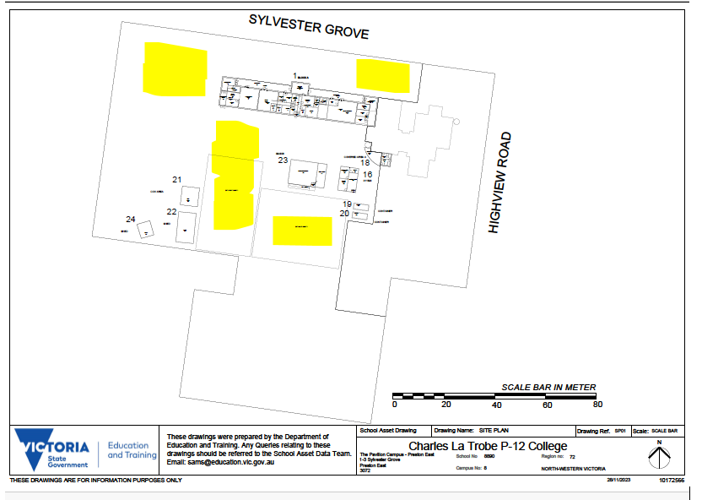

INSERT SCHOOL MAP WITH ZONES MARKED

During yard duty, supervising school staff must:
- methodically move around the designated zones/break areas ensuring active supervision of all students
- where safe to do so, approach any unknown visitor who is observed on school grounds without a clear legitimate purpose, and ensure they have a visitor pass and have signed in.
- Log any incidents or near misses as appropriate [i.e. in Compass, DET Secure Services Hotline if required)
- Teachers and wellbeing staff should monitor and supervise students on breaks and if assessed as necessary (e.g. younger or more vulnerable students), In certain situations, students will be supported to access public transport at either campus
- Be aware that in the school grounds students are usually less contained and more prone to accident and injury than in a more closely supervised classroom
- Be alert and vigilant – intervene immediately if potentially dangerous behaviour is observed in the school grounds
- During transition times supervise students as they go to and from class
- Younger students, students with behavioural difficulties or students with disabilities require a greater level of supervision.
- Always enact duty of care responsibilities even if the student isn’t in your allocated class group.
- Alert Pavilion Principal or coordinator if more supervision is required.
Excursions, incursions and camps
The College Principal and leadership team are responsible for ensuring that students are appropriately supervised during all school activities, camps and excursions, including when external providers are engaged to conduct part or all of the activity. Appropriate supervision will be planned for school activities, camps and excursions on an individual basis, depending on the activities to be undertaken and the level of potential risk involved, and will follow the supervision requirements in the Department of Education and Training Excursions Policy
Pavilion students have been assessed as “at risk” in several risk areas and as such adequate planning and risk assessment should be carried out before any excursion, incursion or camp to ensure duty of care responsibilities are followed. Wellbeing staff members have responsibility for developing behavioural and safety plans and all staff members have responsibility for following any such plan. When planning an excursion, incursion or camp the following should be noted:
- Be aware that students are more likely to display dysregulated behaviour when outside the classroom.
- The teacher in charge will have copies of all confidential medical forms and permission notes with contact details. A copy of this material will also be kept at school
- Arrangements will be made for students not attending to continue their normal program at school under supervision of another classroom teacher
- The teacher in charge or designated teacher of an excursion or camp will carry a mobile phone and a first aid kit
- If the return time from an excursion or camp is delayed, the teacher in charge will contact the school to inform the Principal of the new arrival time so that parents can be contacted and a senior staff member will remain at school until they arrive
- If crossing roads, students are to use designated crossing points. Staff are to walk to the middle of the crossing to ensure visibility and orderly crossing. Other staff control the flow of students across the road
- All staff MUST follow the DET guidelines when organising an excursion, incursion or camp. All procedural steps contained in the school camping, excursions and incursions Policy and Procedure outlines must also be followed.

Digital devices and virtual classroom

The Pavilion follows the Department’s Cybersafety and Responsible Use of Technologies Policy with respect to supervision of students using digital devices.
The Pavilion campus will also ensure appropriate supervision of students participating in remote and flexible learning environments while on school site. In these cases, students will be supervised in accessible classroom spaces contained within their usual classrooms or, if appropriate, in a designated space with supervision provided by al allocated staff member from that students’ triad or an available member of the leadership team.

Some students allocated to “Engage” Classes at The Pavilion may, throughout the year, access their education predominately from home using virtual technology. While parents are responsible for the appropriate supervision of students accessing virtual classrooms from home:
- student attendance will be monitored any wellbeing or safety concerns for the student will be managed in accordance with our usual processes – refer to our Student Wellbeing and Engagement Policy and our Child Safety Responding and Reporting Policy and Procedures for further information

Workplace learning programs

When students are participating in workplace learning programs, such as work experience, school-based apprenticeships and traineeships, and structured workplace learning, the safety and welfare of the student is paramount. Organising staff are required to follow all applicable Department of Education and Training policies and guidelines in relation to off-site learning, including policy and guidelines on the safety and wellbeing of students. Refer to:
- Structure Workplace Learning
- School Based Apprenticeships and Traineeships
- Work Experience
- School Community Work

Duty of care to students outside the school
A number of cases have established that, in some circumstances, a school’s duty (and therefore the Department’s duty) will extend beyond school hours and outside of school

grounds. The duty will be extended to outside school hours and premises when the relationship between the school and the student requires it in the particular circumstances.
At The Pavilion, students will sometimes undertake study at Latrobe University as part of Tertiary Preparation Program. This designated study period occurring off-site will always be supported by an existing Pavilion staff member with access to appropriate communication devices such as a work phone. Students will be expected to access this
Case examples:
In 1977 the High Court found a school authority liable for an injury sustained by a student in the playground 15 minutes before school began for the day (Geyer v Downs). In that case the principal was aware that children were coming onto the grounds before school, and had instructed that children who did so were to read or talk quietly. The Court took the view that in so doing, the principal had brought the school-student relationship into existence and therefore created a duty to ensure that there was adequate supervision before school.
In 1996, a non-government school in NSW (Trustees of the Roman Catholic Church for the Diocese of Bathurst v Koffman) was found liable for an injury to a primary student at an unsupervised bus stop approximately 350 metres from the school and located outside a government secondary school. In that case, the school was aware that a large group of students regularly caught the bus from outside the neighbouring secondary school, and that there was a risk of harm. Moreover, a teacher from the primary school witnessed the incident but did not intervene. The Court found that the teacher-student relationship was still in existence at the time of the injury, and therefore the school authority had a duty of care.
At The Pavilion it is important to note the following:
- Any concerns regarding the safety of a student beyond the school gates should be followed up with school Principal and leadership, parents and police or emergency services if necessary.
- Adequate risk assessments should be conducted by wellbeing staff if there are any concerns for a student’s safety outside of school.
- Whether the duty extends outside of school grounds therefore depends on all the circumstances of each individual case, and the school’s knowledge of any dangers.
- It is important that schools clearly inform parents when school yard supervision will be provided and that no formal supervision of the school yard occurs outside those hours.
Advice to students
Teachers and school staff are frequently called upon to advise students. When doing so they should:
- Limit their advice to students to areas within their own professional competence and given in situations arising from a role specified for them by the principal
- Ensure that the advice they give is correct and in line with the most recent available statements from institutions or employers. Careers teachers and coordinators at senior levels should keep contemporaneous notes of advice given to individuals
- Avoid giving advice in areas unrelated to their role or where they may lack expertise.
Communication of Duty of Care Policy
All staff at The Pavilion campuses will be informed of their legal requirement via:
- A copy of this document will be provided to each member of School staff at the first staff meeting at the commencement of the school year
- New staff will be informed of their Duty of Care as part of the school’s Induction Program
- Duty of Care will be covered in professional development sessions as a whole staff group, in professional learning teams, clinical supervision and during instructional coaching
- This policy will be saved on the share drive
Further Information and Resources
- the Department’s Policy and Advisory Library (PAL):
  - Child Safe Standards
  - Cybersafety and Responsible Use of Technologies
  - Duty of Care
  - Excursions
  - School Based Apprenticeships and Traineeships
  - School Community Work
  - Structured Workplace Learning
  - Supervision of Students
  - Visitors in Schools
  - Work Experience

POLICY REVIEW AND APPROVAL

Policy last reviewed | August 2025
Approved by | College Principal
Next scheduled review date | August 2027

This policy will also be updated if significant changes are made to school grounds that require a revision of The Pavilion’s yard duty and supervision arrangements.

