Yard Duty Policy – Olympic Village PS Campus  (Child Safe) | 
Help for non-English speakers
If you need help to understand this policy, please contact the front office on 9223-1400

Purpose
To ensure school staff understand their supervision and yard duty responsibilities.

Scope

This policy applies to all teaching and non-teaching staff at Charles Latrobe College, including education support staff, casual relief teachers and visiting teachers.

Policy
Appropriate supervision is an important strategy to monitor student behaviour and enables staff to identify and respond to possible risks at school as they arise. It also plays a vital role in helping schools to discharge their duty of care to students.
The Principal is responsible for ensuring that there is a well organised and responsive system of supervision and yard duty in place during school hours, before and after school, and on school excursions and camps and other school activities.
School staff are responsible for following reasonable and lawful instructions from the Principal, including instructions to provide supervision to students at specific dates, times and places. Supervision should be undertaken in a way that identifies and mitigates risks to child safety.

Before and after school
The Olympic Village Primary School Campus grounds are supervised by school staff from 8.45am until 3.30pm. Outside of these hours, school staff will not be available to supervise students.
Before school supervision locations:
Area 1 – includes the area between the admin building and the undercover area, under the COLA and basketball court
Area 2 – includes the playgrounds and sandpit areas
After school supervision locations:
Area 3 – Outside main office to school yard gate
Primary Students
Parents and carers will be advised through newsletter articles, electronic communication and assemblies that they should leave their children at the school or allow them to attend outside of these hours. Families will be encouraged to contact LeapKids Australia on 1300 366 235 or refer to www.leapkids.com.au or enquiries@leapkids.com.au for more information about the before and after school care facilities available to our school community.
If a student arrives at school before supervision commences at the beginning of the day, the Principal or nominee staff member will, as soon as practicable, follow up with the parent/carer to:
- advise of the supervision arrangements before school
- request that the parent/carer make alternate arrangements
If a student is not collected before supervision finishes at the end of the day, the Principal or nominee staff member will consider whether it is appropriate to:
- attempt to contact the parents/carers
- attempt to contact the emergency contacts
- place the student in an out of school hours care program (if available and the parent consents)
- contact Victoria Police and/or Child Protection to arrange for the supervision, care and protection of the student

Yard duty
All staff at the Olympic Village Primary School Campus are expected to assist with yard duty supervision and will be included in the weekly roster.
The Leading Teacher is responsible for preparing and communicating the yard duty roster on a regular basis. the Olympic Village Primary School Campus, school staff will be designated a specific yard duty area to supervise.
Yard duty zones
The designated yard duty areas for our school as at Term 3, 2025 are:
Area | Location
Area 1 | includes the area between the admin building and the undercover area, under the COLA and basketball court
Area 2 | includes the playgrounds and sandpit areas
Area 3 | Outside main office to school yard gate

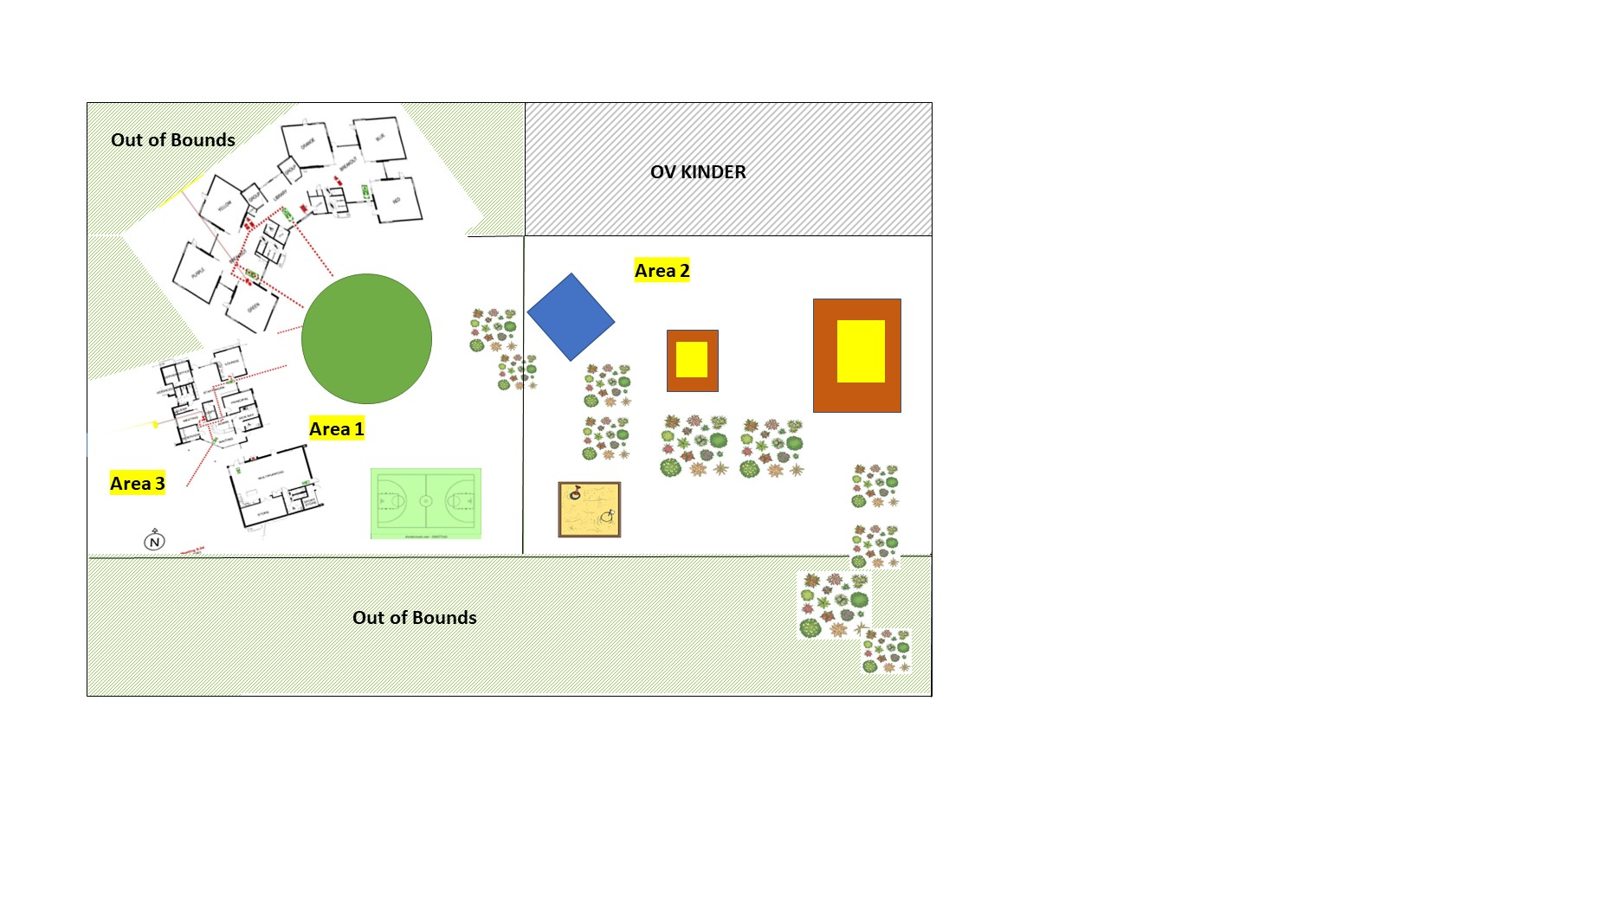
Yard duty equipment
School staff must:
- wear a provided safety/hi-vis vest whilst on yard duty. Safety/hi-vis vests will be provided to each staff member, including CRTs
- Primary teachers always carry the yard duty first aid bag during supervision. The yard duty first aid bag will be provided to each teacher. These first aid bags contain individual student health alert cards should First Aid be required
- Be familiar with the student health and safety information distributed to all staff at the beginning of each Semester
- All staff on yard duty are required to carry their mobile phone with them when on duty
- Staff who are rostered on the Area 11 duty will collect the Stop sign and safety vest from the Office before their duty starts. At the end of the duty the equipment must be returned to the office
Yard duty responsibilities
Staff who are rostered for yard duty must remain in the designated area until they are replaced by a relieving staff member.
During yard duty, supervising school staff must:
- methodically move around the designated zone ensuring active supervision of all students
- ensure students remain in their designated year level zones
- be alert and vigilant
- intervene immediately if potentially dangerous or inappropriate behaviour is observed in the yard
- enforce behavioural standards and implement appropriate consequences for breaches of safety rules, in accordance with any relevant disciplinary measures set out in the school’s Student Engagement policy
- ensure that students who require first aid assistance receive it as soon as practicable
- log any incidents or near misses as appropriate on Compass
If being relieved of their yard duty shift by another staff member (for example, where the shift is ‘split’ into 2 consecutive time periods), the staff member must ensure that a brief, but adequate verbal ‘handover’ is given to the relieving staff member in relation to any issues which may have arisen during the first shift.
If the supervising staff member is unable to conduct yard duty at the designated time, they should contact the Daily Organiser with as much notice as possible prior to the relevant yard duty shift to ensure that alternative arrangements are made.
If the supervising staff member needs to leave yard duty during the allocated time, they should contact the Campus Principal but should not leave the designated area until the relieving staff member has arrived in the designated area.
If the relieving staff member does not arrive for yard duty, the staff member currently on duty should contact the office and not leave the designated area until a relieving staff member has arrived.
Students will be encouraged to speak to the supervising yard duty staff member if they require assistance during recess or lunchtime.

Classroom
The classroom teacher is responsible for the supervision of all students in their care during class.
If a teacher needs to leave the classroom unattended at any time during a lesson, they should first contact a nearby teacher for assistance. The teacher should then wait until a replacement staff member has arrived at the classroom before leaving.

School activities, camps, and excursions
The Principal and leadership team are responsible for ensuring that students are appropriately supervised during all school activities, camps, and excursions, including when external providers are engaged to conduct part or all of the activity. Appropriate supervision will be planned for school activities, camps and excursions on an individual basis, depending on the activities to be undertaken and the level of potential risk involved, and will follow the supervision requirements in the Department of Education and Training Excursions Policy.

Students requiring additional supervision support
Sometimes students will require additional supervision, such as students with disability or other additional needs. In these cases, the Principal or delegate will ensure arrangements are made to roster additional staff as required. This may include on yard duty, in the classroom or during school activities.

Supervision of student in emergency operating environments
In emergency circumstances our school will follow our Emergency Management Plan, including with respect to supervision.
In the event of any mandatory period of remote or flexible learning our School will follow the operations guidance issued by the Department.
COMMUNICATION

This policy will be communicated to our school community in the following ways:

- Included in staff induction processes
- Discussed at staff briefings or meetings, as required
- Included in our staff handbook
- Included as a reference in our school newsletter/electronic communication each Year
- Made available in hard copy from school administration upon request
Information for parents and students on supervision before and after school is available on our school website and parent reminders are sent at the beginning of each term in our school newsletter.

Further Information and Resources
- the Department’s Policy and Advisory Library (PAL):
  - Child Safe Standards
  - Cybersafety and Responsible Use of Technologies
  - Duty of Care
  - Excursions
  - School Based Apprenticeships and Traineeships
  - School Community Work
  - Structured Workplace Learning
  - Supervision of Students
  - Visitors in Schools
  - Work Experience

POLICY REVIEW AND APPROVAL

Policy last reviewed | July 2025
Approved by | Principal
Next scheduled review date | July 2027

This policy will also be updated if significant changes are made to school grounds that require a revision of Charles Latrobe P-12 College’s yard duty and supervision arrangements.

