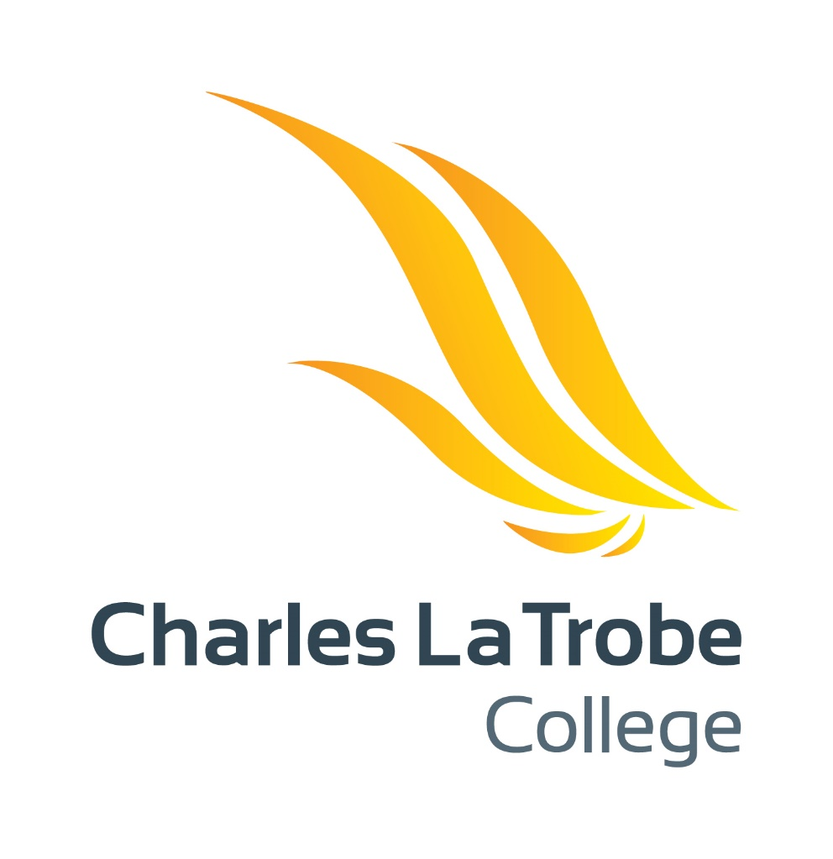

Parent & Student
Acceptable ICT User Agreement

Charles La Trobe P-12 College - Secondary School
Parent & Student Acceptable ICT User Agreement 2021

This page is deliberately blank

Contents
Part A: School Support for the Safe and Responsible Use of ICT Technologies 4
Part B: Parent & Student College ICT, Bring Your Own Device (BYOD) and Online Services Agreement 5
ICT User Agreement Application 5
Social Media Online Services & Applications 6
Social Media Online Services & Applications Agreement 7
Curriculum Content Sharing Online Services & Applications 8
Curriculum Content Sharing Online Services & Applications Agreement 10
College Online Services & Applications 11
College Online Services & Applications Agreement 14
Part C: Parent & Student Authorization Form 17
Parent and Student 2021 ICT User Agreement Consent 17

Part A: School Support for the Safe and Responsible Use of ICT Technologies

Charles La Trobe P-12 College uses the Internet, Student and Parent Online Services & Applications and Digital Technologies as teaching and learning tools. We see these tools as valuable resources, but acknowledge they must be used responsibly.

You and your child have been asked to agree to the responsible use of Internet, Student and Parent Online Services and Digital Technologies provided by the College. Parents/Carers should be aware that the nature of the internet is such that full protection from inappropriate content can never be guaranteed.

The agreement is valid for the life of your child’s enrolment at Charles La Trobe P-12 College. Any minor changes made to the agreement, an addendum will be sent out to parents/carers. Any major changes made to the agreement will be reviewed and the agreement re-issued.

This User agreement incorporates the safe and responsible use of ICT and Online Services & Applications provided by the College. These Services have been outlines in Part B of this Article,

At Charles La Trobe P-12 College we:
- provide a College Internet service that is filtered to only access content that is deemed necessary for learning
- provide access to the Department of Education and Training (DET) online services
- provide supervision and direction in online activities and when using digital technologies for learning
- support students in developing digital literacy skills
- enforce the Department of Education and Training (DET) Cyber Safety program. To assist parents please see: https://esafety.gov.au/esafety-information
- use mobile technologies for learning purposes at schools. (e.g. taking photos for a school based project)
- provide support to parents/carers to understand this agreement (e.g. language support)
- work with students to outline and reinforce the expected behaviours when using Online Services provided by the college.
- developed network monitoring tools to ensure user activity is monitored and suspicious or malicious activities are accounted for

By accepting this agreement and connecting a device to the Charles La Trobe P-12 College Network you agree to abide by the following conditions:
- Consent to deep packet filtering and investigation of all data packets sent and received
- Installation of a network activity monitoring script

Part B: Parent & Student College ICT and Online Services Agreement

For the use of all ICT Technologies at Charles La Trobe P-12 College
When I use digital technology I agree to:
- abide by the Department of Education and Training (DET) ICT acceptable use policy – refer to link: http://www.education.vic.gov.au/school/principals/infrastructure/Pages/acceptableuse.aspx
- be a safe, responsible and ethical user whenever and wherever I use it
- support others by being respectful in how I communicate with them and never write or participate in online bullying (this includes forwarding messages and supporting others in harmful, inappropriate or hurtful online behaviour)
- talk to a teacher if I feel uncomfortable or unsafe online or see others participating in unsafe, inappropriate or hurtful online behaviour
- seek to understand the terms and conditions of websites and online communities and be aware that content I upload or post is my digital footprint
- protect my privacy rights and those of other students by not giving out personal details including full names, telephone numbers, addresses and images
- use the internet for educational purposes and use the equipment properly
- use social networking sites for educational purposes and only as directed by teachers
- abide by copyright procedures when using content on websites (ask permission to use images, text, audio and video and cite references where necessary)
- think critically about other users’ intellectual property and how I use content posted on the internet.
- not interfere with network security, the data of another user or attempt to log into the network with a user name or password of another student
- not reveal my password to anyone except the system administrator or the teacher
- not bring or download unauthorized programs, including games, to the school or run them on school computers.
- not connect to any other internet source other than the school provided Internet Service Provider (ISP). This includes; connecting to Wireless Hotspots, Bluetooth and other internet devices.
- Not use VPN (Virtual Private Network) services on my device when connected to the CLTC network

When I use other ICT equipment not provided by Charles La Trobe P-12 College (E.g. mobile phones) I agree to:
- only take photos and record sound or video when it is part of an approved lesson
- seek permission from individuals involved before taking photos, recording sound or videoing them (including teachers)
- seek appropriate (written) permission from individuals involved before publishing or sending photos, recorded sound or video to anyone else or to any online space
- be respectful in the photos I take or video I capture and never use these as a tool for bullying or harassment of others
- not access any material online that is not school related.
Failure to comply with the above conditions will be brought to the attention of the relevant Assistant Principal. They will collaborate with the College's ICT Department to work out an appropriate consequence, which may include network access suspension.

ICT User Agreement Application
This Acceptable ICT Agreement also applies during school excursions, camps and extra-curricular activities. As a Parent and Student of Charles La Trobe P-12 College:
- I acknowledge and agree to follow these rules.
- I understand that my access to College ICT Services, Online Applications, Internet and BYOD Access at school will be renegotiated if I do not act responsibly.

Social Media Online Services & Applications
The College uses social media to allow collaboration and to promote what is happening in the school for the wider community. The College does not promote Social Media access for students and restricts student access of some Social Media platforms (including Facebook, YouTube, Instagram, Snapchat, WhatsApp, Facebook Messenger). Students using or accessing any unrestricted social media platforms will have their data and activities monitored.

Students that decide to use other networks (mobile or 3/4/5G Internet services) to access Social Networking will not be monitored as Charles La Trobe P-12 College does not have the tools or permissions to monitor these networks.

If families have concerns in regard to your child accessing Social Media, please contact the College and we will make arrangements to meet your requirements.

The table below provides information for parents and students on information relating to privacy and policy when using Social Media in Charles La Trobe P-12 College:

Privacy Policy Link | The Policy will depend on the service:  Facebook: https://www.facebook.com/about/privacy  Twitter: https://twitter.com/privacy  Instagram: https://instagram.com/about/legal/privacy/
What does the online service provide? | Social Media will provide staff and students with a way of collaboration. The College will use social media as a public announcement space.
Who is the Service Provider? | The Service Provider will depend on the service:  Facebook: Facebook, Inc.  Twitter: Twitter, Inc.  Instagram: Facebook, Inc.
What personal information of individuals will the school use and disclose to the service provider? | Personal information will depend on what the student or staff member decides to share via the privacy tools on each social media site.  Charles La Trobe P-12 College will have no power over the control of these accounts nor will take any responsibility for them.  Parents are strongly advised to sit down and review their child’s social media account privacy settings to ensure that their details are not exposed to the world and that they are of legal age to have an account.
How will the school use the personal information of individuals? | When the College utilizes social media it will be used for classroom purposes. The amount of personal information shared is up-to the student as the College does not have access to the student’s accounts and privacy settings.  The College cannot ensure that other students will not disclose other student’s personal data using social media. To assist with preventing this from happening the college advises all parents to use resources like the Australian Government Cyber Safety site which has a dedicated section on Social  Networking:  https://esafety.gov.au/esafety-information/games-apps-and-social-networking  As stated previously in this document the College will monitor all Social Media activity on the Charles La Trobe P-12 College ICT Network.
Where will the service provider store the personal information disclosed to it? | These Social Media online applications store their data outside of Australia. The exact location of where the data is stored cannot be verified and is likely to change often.
What school policies apply to the use of these online services? | Student Engagement Policy  Student Behaviour Policy  Internet & Social Media Policy  Staff Social Media Policy
Will the School be able to access and retrieve all content including messages or other communications from the online services? | The College cannot guarantee the retrieval of data from Social Networking sources as they are not the account holders.  Any work or activities done on social media accounts by the user is only accessible by them. The College does not have any access to these accounts.
How will the service provider use personal information of individuals that is collected from the school? | Use of data on Social Media Networking sites is purely dependent on the privacy settings of the user and how they handle their data while using the Social Media sites.  It is well documented that social media sites tend to fund their operations by selling non-identifiable data to third party organizations.
Who will be able to see the content and work? | Permissions to see data on Social Media Networking sites is purely dependent on the privacy settings of the user and how they handle their data while using the Social Media sites.
Whilst Students own copyright in the work they product, who will have rights to reproduce and/or use the works? | Reproductions rights on Social Media Networking sites is purely dependent on the privacy settings of the user and how they handle their data while using the Social Media sites.  Social Media sites have also been known to take ownership of intellectual property as soon as something is uploaded or created on the site.

Social Media Online Services & Applications Agreement
By signing the agreement, you are accepting the use of the Social Media Online Services & Applications as specified.

You are also acknowledging that the College may not be able to assist if your child attempts to access a Social Media Online Services & Applications outside of the Charles La Trobe P-12 College ICT Network.

Curriculum Content Sharing Online Services & Applications
In supporting student learning, staff across the college may look at utilizing many online learning applications and utilities to:
- Improve Learning Outcomes
- Increase Collaboration among both students and staff
- Improve the work flow process of classes

Staff will be required to read and check the privacy policies and how the data will be handled by the online service provider. They will also ensure that parents and students are notified of the tools they will be using online before allowing that student to access the resource they wish to use.

Privacy Policy Link | The Policy will depend on the service:  Padlet: http://jn.padlet.com/article/32-privacy-policy  Quizlet: http://quizlet.com/privacy  Socarative: http://www.socrative.com/privacy.php  Nearpod: https://nearpod.com/privacy-policy/  Youtube: https://www.youtube.com/static?&template=privacy_guidelines  Kahoot: https://getkahoot.com/info/privacy-policy  AutoDesk Online: http://www.autodesk.com/company/legal-notices-trademarks/privacy-statement/autodesk-privacy-statement-2012-english  Scratch: https://scratch.mit.edu/privacy_policy/  Seesaw: http://www.showbie.com/privacy/ (Primary)  Canva: http://www.canva.com
What does the online service provide? | These online services provide a variety of ways for students to collaborate via different mediums.  This services might be used in classes by our teachers to support the curriculum being taught within the class.  Students will tend to be completing curriculum set tasks on these applications, as set out by their teachers.
Who is the Service Provider? | The Service Provider will depend on the service:  Padlet: Padlet, Inc.  Quizlet: Quizlet LLC  Socrative: Socrative. Inc.  Nearpod: Nearpod™  You Tube: Google, Inc.  Kahoot: Kahoot! AS  AutoDesk Online: Autodesk, Inc.  Scratch: MIT Media Lab  Showbie: Seesaw Learning, Inc.  Canva: Canva Pty Ltd
What personal information of individuals will the school use and disclose to the service provider? | The following personal information will be used on these sites:  - First Name  - Last Name  - School Email Address  - Photo/’s of Students  - Video/’s of Students  - Student school work  - Marking Work
How will the school use the personal information of individuals? | The school will use these tools to support the collaboration and learning of students in various ways.  When using this personal information it will only be used to identify the user online. No data like Date of Birth and Home or School addresses will be used.  Students might be asked to upload photos and videos that are to be used to support a task set out by their teacher.  They may also be asked to submit work they have completed on the online service or using an offline application. Some teachers may use the tools to assist with their marking. No official reporting or assessment will be done on these online platforms.
Where will the service provider store the personal information disclosed to it? | All the sites that has been mentioned previously all reside outside of Australia.  In most cases these services will not say where the data is being stored exactly.  For more information please refer to the privacy links provided.
What school policies apply to the use of these online services? | Student Engagement Policy  Student Behaviour Policy  Internet & Social Media Policy  Staff Social Media Policy
Will the School be able to access and retrieve all content including messages or other communications from the online services? | These services have been selected as they have associated tools to allow teachers to administer and monitor the online activities.  They also provide access rules and tools that don’t allow the data to be publicly broadcasted.  Data retrieval is currently possible from these services, though we cannot guarantee this will not change.
How will the service provider use personal information of individuals that is collected from the school? | Quizlet: Does not sell any of its data to 3rd party companies and keeps its data private.  Padlet: They may share or disclose non-private information, Aggregate Information, or other non-Personal Information with people and entities that they do business with.  Socrative: Does not sell any of its data to 3rd party companies and keeps its data private.  YouTube: Uses your data to assist with providing Advertising and can provide anonymous non-identifiable data to third parties.  Kahoot: Stores data like answers to quizzes though does not associate this to an account. Does not sell, rent, trade or otherwise disclose personal and associated account information about website users.  AutoDesk Online: They may share or disclose non-private information, Aggregate Information, or other non-Personal Information with people and entities that they do business with.  Scratch: Does not sell any of its data to 3rd party companies and keeps its data private.  Seesaw: Does not sell any of its data to 3rd party companies and keeps its data private.
Who will be able to see the content and work? | These applications have been chosen as they provide tools to block access to public users viewing the online data.  Staff will be trained on how to use these tools to ensure data is secure.  Steps will be taken to reduce the risk of identification of student’s identity for any data that is made public.
Whilst Students own copyright in the work they produce who will have rights to reproduce and/or use the works? | The College will ensure that all steps will be taken to ensure intellectual property ownership belongs to the College and student only.  During the course of the year the online service a student uses may change their privacy policy. In this instance we cannot guarantee the ownership of the Intellectual Property of a students work will remain the student’s and College’s.

Curriculum Content Sharing Online Services & Applications Agreement
By signing the agreement, you are accepting the use of the Curriculum Content Sharing Online Services & Applications as specified.

College Online Services & Applications
The College will be utilizing three College wide applications in Secondary School that will be hosted online. These applications are Compass School Manager, Microsoft Office 365 and Student Performance Analyser. To comply with the Department of Education and Training (DET) Online Services policies and legal requirements we must disclose all details of where, how, what and why the data will be stored on these applications.

The following table details all information about the cloud services Compass School Manager, Microsoft Office 365 and Student Performance Analyser:
 | COMPASS SCHOOL MANAGER | MICROSOFT OFFICE 365 | STUDENT PERFORMANCE ANALYSER
Privacy Policy Link | http://compass.edu.au/Corporate/privacy/ | http://office.microsoft.com/en-au/business/office-365-cloud-privacy-FX103046091.aspx | http://www.spaplatform.com.au/terms-privacy
What does the online service provide? | Allows for central Administration and communication for Staff, students and Parents. Services include:  - Attendance  - Wellbeing  - Room Resource Bookings  - Reporting  - Parent portal access  - Events (Excursions, camps etc.)  - College Calendar  - News items | Central online storage and collaboration service for staff and students of the college. Services include:  - Email  - SharePoint  - OneDrive  - Skype for Business  - Office Applications Online  - Sway  - Yammer  - Video  - Office Mix  - OneNote | Allows for the analysis, display and communication of assessment data.
Who is the Service Provider? | JDLF International Pty Ltd | Microsoft Corporation | Orchard Downs Pty Ltd
 | COMPASS SCHOOL MANAGER | MICROSOFT OFFICE 365 | STUDENT PERFORMANCE ANALYSER
What personal information of individuals will the school use and disclose to the service provider? | Students:  - Full Name  - Contact information including: Address, Phone and Email.  - Wellbeing Data  - Medical Information  - Attendance Information  - Report Information  - Network User Account Information  Parents:  - Full Name  - Contact information including Address, Phone and Email.  Parent Portal Username and Password information. | Students (Only):  - Personal Data  - First Name  - Last Name  - School Email Address  - School Network Information  - Learning & Curriculum Data  - Assessment Data | Students (Only):  - Personal Data  - First Name  - Last Name  - School Email Address  - School Network Information  - Learning & Curriculum Data  Assessment & Analytical Data
 | COMPASS SCHOOL MANAGER | MICROSOFT OFFICE 365 | STUDENT PERFORMANCE ANALYSER
How will the school use the personal information of individuals? | Students:  - Access to this information will be controlled and monitored.  - Full name and Contact Information: made available so staff are able to contact relevant parties for various issues  - Wellbeing Data: Tracking student wellbeing and being to track this effectively.  - Medical Information: alerts staff to issues and are able to take necessary actions in regards to medical incidents.  - Attendance Information: Staff will mark student data and ensure that students are meeting college attendance requirements.  - Report Information: Reports will be uploaded to the site for parents to access.  - Network User Information: Allows students to access the Compass School Manager Service.  Parents:  - Access to this information will be controlled and monitored.  - Full name and Contact Information: made available so staff are able to contact relevant parties for various issues  - Parent Portal Username and Password Information: Used to access the parent portal on Compass School Manage | Students (Only):  - Personal Data: Students personal drives will be hosted on the office 365 application. Similar to a Dropbox setup. They will also utilize some applications to complete set tasks that require their Name and User Account information associated to the Office 365 Application.  - Learning & Curriculum Data: Any work that a student has done will be hosted on Office 365.  - Assessment Data: Staff will from time-to-time will complete some spreadsheets with student results on them. This will be secured down so only staff can access it. | Students:  - Personal Data: Information like first name, last name and student identifying number will be entered into the assessment system.  - Learning & Curriculum Data: Staff will place Assessment data that will be hosted on SPA.  - Assessment Data: Staff will enter student results in to SPA. Only Staff access SPA.
 | COMPASS SCHOOL MANAGER | MICROSOFT OFFICE 365 | STUDENT PERFORMANCE ANALYSER
Where will the service provider store the personal information disclosed to it? | Various locations around Metropolitan Melbourne, Australia. This is also hosted within the DET Vicsmart ICT Network. | Three locations store Microsoft Office 365 Education:  - Melbourne  - Sydney  - United States of America (USA) authentication only no personal data used (School Username and Password) | The data is securely hosted on Australian servers with backups to internal Australian servers.
What school policies apply to the use of these online services? | Student Engagement Policy  Student Behaviour Policy  Internet & Social Media Policy  Staff Social Media Policy
Will the School be able to access and retrieve all content including messages or other communications from the online services? | All of these applications will have tools installed and service teams that will allow the college to adequately track usage on these services.
How will the service provider use personal information of individuals that is collected from the school? | Compass School Manager does not share any information unless they have strict consent from Charles La Trobe P-12 College. The college will not consent any data without the strict written consent of the parent and guardians of the concerned children. | Data is not mined for educational purposes and the ownership remains the property of Charles La Trobe P-12 College. | Data is not mined for educational purposes and the ownership remains the property of Charles La Trobe P-12 College.
Who will be able to see the content and work? | Users will be need to be registered users of the Charles La Trobe P-12 College ICT Network. Access to technical materials will be required at times by both vendors. These vendors require strict permission before viewing any of the data.  User permissions will be determined by the college ICT Manager, E-Learning Coordinator and College Leadership team.
Whilst Students own copyright in the work they product, who will have rights to reproduce and/or use the works? | Both services state that the data remains the property of Charles La Trobe P-12 College, meaning the college reserves to the right only to decide this. Written consent from a parent or guardian will be required before allowing any data to go outside the college.

College Online Services & Applications Agreement

By signing the agreement, you are accepting the use of the College Online Services & Applications as specified.

You are also acknowledging that the College might use other online Services & Applications outside of those mentioned in this agreement.

If this is the case, parents will be alerted to the new online Services & Applications use, and further consent will need to be given.

This page is deliberately blank

Part C: Parent & Student Authorization Form

For the use of all ICT Technologies and Online Services at Charles La Trobe P-12 College. Please return this signed section the office by 27th January 2021. Without this agreement returned your child will not have access to the CLTC ICT Resources. This agreement is not in relation to the device agreements and will incur no cost. Any questions or queries you may have in regards to this agreement should be directed to the college.

By signing below, the Parent has read and explained the Charles La Trobe P-12 College Acceptable ICT User Agreement 2021 carefully to the student and together understands the significance of the terms and conditions and agrees to abide by them.

The Parent and Student agrees that Charles La Trobe P-12 College reserves the right to make amendments to the Parent and Student Acceptable ICT User Agreement at any time. The College also reserves the right to default or suspend access to ICT resources should there be a significant breech to the terms and conditions set out in this agreement.

The Parent and Student consents to the following being made available on the College’s Online Services:
  - Authorize permission for your child and parent/guardian to access the Online Services and Applications including:
    - Social Media Online Services & Application
    - Curriculum Content Sharing Online Services & Application
    - College Online Services & Application
As outlined in Part B of this agreement.
  - Allow the personal information to be uploaded to these Service’s and Application’s as specified in Part B of this agreement including the data being stored outside of Victoria.
  - Enable the use of an individual’s intellectual property as specified in Part B of this agreement.

Parent and Student 2021 ICT User Agreement Consent
Student Name: ………………………………………………......................... | Year Level: ……………………………………
Student Signature  (Year 5 & 6 Only): …………………………………………………………………………………… |  | Date: …………………………
Parent/Guardian Name (All Year Levels): …………………………………………………………………………………............
Parent/Guardian Signature: ………………………………………………………………………… |  | Date: …………………………

All data received and sent on your device will be monitored by network technicians, stored and subject to review

